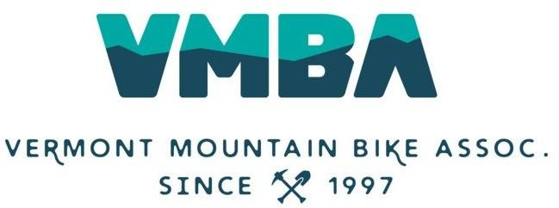

Employment Agreement

This agreement is made as of the ____ day of ________, 2022, between VMBA (employer) and ____________ (employee). Please indicate your agreement with the below compensation for the calendar year 2022. _________ (Chapter) will pay an [indicate hourly or salary] of $[amount] per [hour or year].

- Employment

Employee agrees to, at all times, and to the best of their ability to perform all duties required of this position. In doing so, they agree to follow all VMBA employment policies found in the Employee Handbook, this includes but not limited to At-Will Notice, Introductory Period, General Conduct Guidelines, Workplace Guidelines, and Employment Separation.

- Position Title & Description

As Chapter’s [Position Title], the employee will [position summary, 2-3 sentences].

- Compensation & Benefits Summary

- [Annual Base Salary or Hourly Wage] of $[amount] paid bi-weekly
- Health stipend of $[amount] to be used at your personal discretion
- Participation in VMBA’s SIMPLE IRA up to a 3% match
- Professional Development opportunities as approved by Chapter
- Chapter may elect to provide bonuses and/or raises at its discretion
- [# days] paid vacation days
- [# days] paid sick leave days
- Paid Holidays include: New Years Day, MLK Day, President’s Day, Memorial Day, Juneteenth, Independence Day, Labor Day, Indigenous Peoples’ Day, Thanksgiving Day, Friday after Thanksgiving, Christmas Eve, Christmas Day

Date Chapter Signature

Date Employee Signature

Vermont Mountain Bike Association
PO Box 2055, South Burlington VT 05407

